**8.Consider the rainfall dataset. This data contains region(district) wise rainfall across India. Perform the following operations for the dataset**

**a.Find the district that gets the highest annual rainfall.**

**b.Drop the columns 'Jan-Feb', 'Mar-May', 'Jun-Sep', 'Oct-Dec'.**

**c. Display the state-wise mean rainfall for all the months using a pivot table.**

import pandas as pd

df = pd.read_csv ('District_Rainfall_Normal_0.csv')

#Find the district that gets the highest annual rainfall

y =df.groupby('STATE/UT').aggregate({'JAN':'mean'})

print(y)

df.describe()

import pandas as pd

df = pd.read_csv ('District_Rainfall_Normal_0.csv')

df.drop(columns=['JAN','FEB','MAR','MAY','JUN','SEP','OCT','DEC'], inplace=True)

df

**OUTPUT:**

STATE/UT

ANDAMAN And NICOBAR ISLANDS 61.233333

ANDHRA PRADESH 6.321739

ARUNACHAL PRADESH 53.687500

ASSAM 15.733333

BIHAR 13.134211

CHANDIGARH 44.300000

CHATISGARH 10.377778

DADAR NAGAR HAVELI 0.400000

DAMAN AND DUI 0.550000

DELHI 16.400000

GOA 0.550000

GUJARAT 0.784615

HARYANA 19.485714

HIMACHAL 81.925000

JAMMU AND KASHMIR 77.977273

JHARKHAND 15.837500

KARNATAKA 2.026667

KERALA 9.542857

LAKSHADWEEP 20.800000

MADHYA PRADESH 12.892000

MAHARASHTRA 4.791429

MANIPUR 22.600000

MEGHALAYA 14.900000

MIZORAM 11.566667

NAGALAND 18.481818

ORISSA 10.810000

PONDICHERRY 26.750000

PUNJAB 25.965000

RAJASTHAN 5.348485

SIKKIM 47.550000

TAMIL NADU 18.906250

TRIPURA 11.225000

UTTAR PRADESH 17.183099

UTTARANCHAL 49.892308

WEST BENGAL 15.031579

Out[3]:

|  | **STATE/UT** | **DISTRICT** | **APR** | **JUL** | **AUG** | **NOV** | **ANNUAL** | **JAN+FEB** | **MAM** | **JJAS** | **OND** |
| --- | --- | --- | --- | --- | --- | --- | --- | --- | --- | --- | --- |
| **0** | ANDAMAN And NICOBAR ISLANDS | NICOBAR | 117.0 | 285.0 | 271.9 | 315.2 | 2805.2 | 165.2 | 540.7 | 1207.2 | 892.1 |
| **1** | ANDAMAN And NICOBAR ISLANDS | SOUTH ANDAMAN | 90.5 | 421.3 | 423.1 | 275.8 | 3015.7 | 69.7 | 483.5 | 1757.2 | 705.3 |
| **2** | ANDAMAN And NICOBAR ISLANDS | N & M ANDAMAN | 53.4 | 465.4 | 460.9 | 198.6 | 2913.3 | 48.6 | 405.6 | 1884.4 | 574.7 |
| **3** | ARUNACHAL PRADESH | LOHIT | 358.5 | 660.1 | 427.8 | 34.1 | 3043.8 | 123.0 | 841.3 | 1848.5 | 231.0 |
| **4** | ARUNACHAL PRADESH | EAST SIANG | 216.5 | 990.9 | 711.2 | 29.5 | 4034.7 | 112.8 | 645.4 | 3008.4 | 268.1 |
| **...** | ... | ... | ... | ... | ... | ... | ... | ... | ... | ... | ... |
| **636** | KERALA | IDUKKI | 150.4 | 788.9 | 527.3 | 172.9 | 3302.5 | 35.5 | 426.6 | 2276.2 | 564.2 |
| **637** | KERALA | KASARGOD | 46.9 | 1108.5 | 636.3 | 84.6 | 3621.6 | 3.3 | 272.9 | 3007.5 | 337.9 |
| **638** | KERALA | PATHANAMTHITTA | 184.9 | 539.9 | 352.7 | 213.5 | 2958.4 | 65.0 | 553.5 | 1715.7 | 624.2 |
| **639** | KERALA | WAYANAD | 83.3 | 1110.4 | 592.9 | 93.6 | 3253.1 | 13.1 | 275.4 | 2632.1 | 332.5 |
| **640** | LAKSHADWEEP | LAKSHADWEEP | 48.9 | 287.7 | 217.5 | 117.7 | 1600.0 | 35.5 | 232.4 | 998.5 | 333.6 |

641 rows × 11 columns

**9)In recent Your most of the Companies are turning to text based chat box for resolving Consumer queries. What is the reason for it & how is it impacting the business**.

**B) Chess game / online trading /cyber-attack / not entertainment Shopping/Medical Services (health care).**

The traditional way of customers falls short when it comes to meeting the constantly evolving expectation of new age customers. So business are changing the ways to give a greater experience to customers at every step of their journey. It's where AI enabled customers service or chatbots make their way into the business. with 50% of consumers no longer caring whether they dealing with AI or humans, these bots can definitely fill the gap in the customers support

So what is a Customers service chatbot?

These both are designed specifically with an objective of serving purpose along the customers Journey. The smart customer care bot can answer up to 70% of simple FAQ-oriented customer query or direct customers to find addition information or sources on your website

Advantages of customer service chatbot

* Provide instant support
* Delivery a better experiences
* Available 24/7
* Minimize customers support cost
* Track customers satisfaction
* Collect real time feed back

**10)assume proper dataset and apply different kinds plots using matplotlib**

import matplotlib.pyplot as plt

import pandas as pd

df = pd.read_csv('car.csv')

x=df.wt

y=df.mpg

plt.xlabel('Weight')

plt.ylabel('Mpg')

plt.scatter(x,y)

plt.title('scater plot')

plt.show()

e = df.wt

u = df.model

plt.plot(e,u)

plt.title('line graph')

plt.show()

y= df.mpg

plt.hist(y, bins = 5 ,);

plt.title('histogram')

plt.show()

a=df.trans

b=df.model

plt.xlabel('TRANSMISSION TYPE')

plt.ylabel('MODEL')

plt.bar(a,b,color ='red',edgecolor='black',linewidth=5 )

plt.title('bar graph')

plt.show()

plt.pie(a, labels=b)

plt.title("Pie Chart")

cols = ['b','c','g', 'orange']

plt.pie(a,

labels =b,

colors = cols,

startangle = 90,

shadow = True,

autopct ='%0.2f%%')

plt.show()

import seaborn as sns

# adding data points

sns.boxplot(df['hp'])

plt.title('box plot')

# display plot

plt.show()

**OUTPUT**

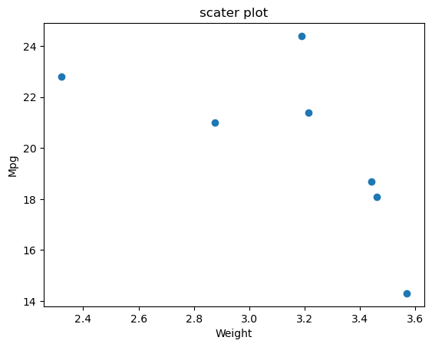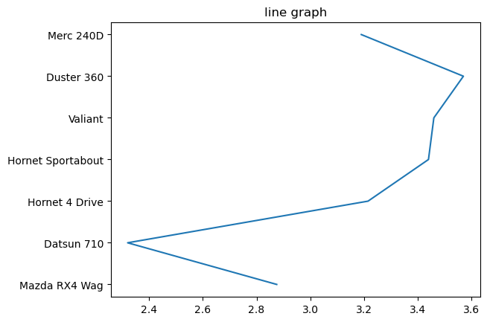

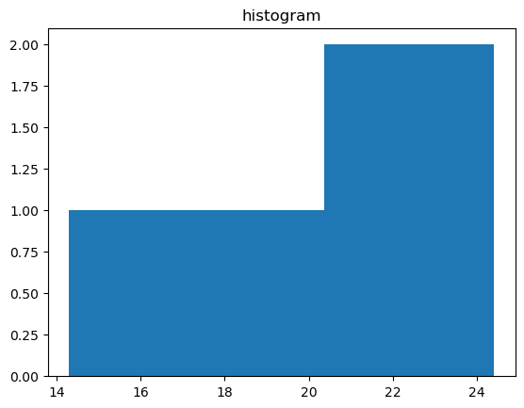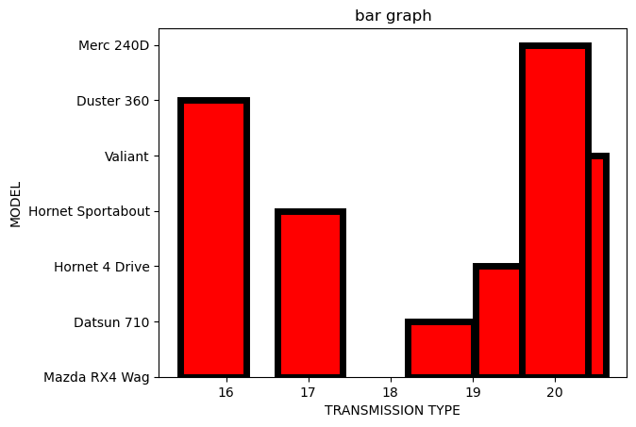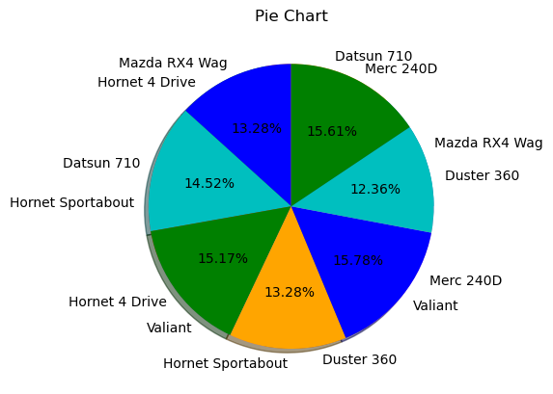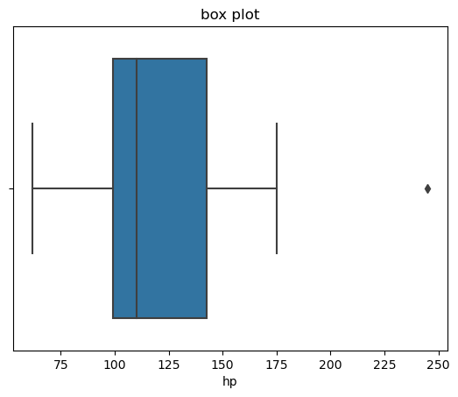

**11)assume stock data set and visualize time series data using pandas**

[**https://github.com/mansi75/Stock-Market-Prediction (download**](https://github.com/mansi75/Stock-Market-Prediction%20(download) **the dataset from this link)**

import pandas as pd

import matplotlib.pyplot as plt

df=pd.read_csv('stock.csv')

df

**OUTPUT:**

|  | **Date** | **Open** | **High** | **Low** | **Last** | **Close** | **Total Trade Quantity** | **Turnover (Lacs)** |
| --- | --- | --- | --- | --- | --- | --- | --- | --- |
| **0** | 08-10-2018 | 208.00 | 222.25 | 206.85 | 216.00 | 215.15 | 4642146 | 10062.83 |
| **1** | 05-10-2018 | 217.00 | 218.60 | 205.90 | 210.25 | 209.20 | 3519515 | 7407.06 |
| **2** | 04-10-2018 | 223.50 | 227.80 | 216.15 | 217.25 | 218.20 | 1728786 | 3815.79 |
| **3** | 03-10-2018 | 230.00 | 237.50 | 225.75 | 226.45 | 227.60 | 1708590 | 3960.27 |
| **4** | 01-10-2018 | 234.55 | 234.60 | 221.05 | 230.30 | 230.90 | 1534749 | 3486.05 |
| **...** | ... | ... | ... | ... | ... | ... | ... | ... |
| **1230** | 14-10-2013 | 160.85 | 161.45 | 157.70 | 159.30 | 159.45 | 1281419 | 2039.09 |
| **1231** | 11-10-2013 | 161.15 | 163.45 | 159.00 | 159.80 | 160.05 | 1880046 | 3030.76 |
| **1232** | 10-10-2013 | 156.00 | 160.80 | 155.85 | 160.30 | 160.15 | 3124853 | 4978.80 |
| **1233** | 09-10-2013 | 155.70 | 158.20 | 154.15 | 155.30 | 155.55 | 2049580 | 3204.49 |
| **1234** | 08-10-2013 | 157.00 | 157.80 | 155.20 | 155.80 | 155.80 | 1720413 | 2688.94 |

1235 rows × 8 columns

df['Open'] = pd.to_datetime(df['Open'])

df.dtypes

df = df.set_index('Open')

df

x=df.index

plt.plot(x)

df['Close'] = pd.to_datetime(df['Close'])

df.dtypes

df = df.set_index('Close')

df

x=df.index

plt.plot(x)

**OUTPUT**

[<matplotlib.lines.Line2D at 0x1e6373b0e50>]

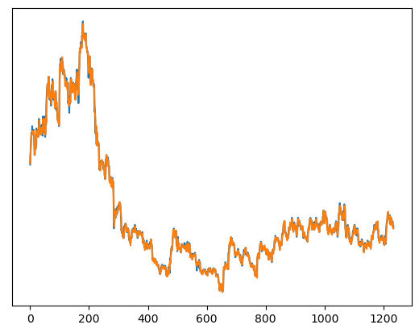

**11)b) With Industry 4.0, artificial intelligence is finding place in every aspect of life. What happens if Al replaces humans in the workplace?**

AI is and will continue to replace some jobs. Workers in industries ranging from healthcare to agriculture and industrial sectors can all expect to see disruptions in hiring due to AI. But demand for workers, especially in robotics and software engineering, are expected to rise thanks to AI.

We’ve seen robots replace human jobs and a robot has some form of AI in it to ensure it functions and knows what job it’s doing.

AI is evolving and technology is having an increasingly bigger role, but it will complement and augment most jobs, not replace them. In a study involving 1500 companies, researchers found that the most significant performance improvements occurred when humans and machines worked together.

Artificial intelligence's impact on society is widely debated. Many argue that AI improves the quality of everyday life by doing routine and even complicated tasks better than humans can, making life simpler, safer, and more efficient.

<https://builtin.com/artificial-intelligence/ai-replacing-jobs-creating-jobs>

12) For the given scenarios you are required to build an Al solution. Which Al techniques can be applied/best suited for stated problems. Justify

a)Extract and digitize the customer information from the Know Your Customer (KYC)

b)To identify if employees are wearing face mask in the office campus

c)To identify and narrow down tumour regions and further predict if the tumour is process

d)To identify the location of a moving car within an image

Automated inspection and cost estimation step in the Insurance claim business

1 AI in KYC can facilitate onboarding by applying optical character recognition. Thus, instead of manually scanning through documents, companies adopt an OCR-based process:

The customer begins the identification check by taking a snapshot of their ID and uploading it.

The software retrieves all data, including signatures and photographs, and turns it into a computer-readable format.

The new customer will then see the extracted data automatically placed in the form and will only need to validate it.

2 Face Mask Detection Platform uses Artificial Network to recognize is a user is not wearing a mask

Face Mask Detection System by using existing cameras combined with Trident Computer Vision platform to detect people without masks.

Face Mask Detection Platform uses Artificial Network to recognize if a user is wearing or not wearing a mask.

If the camera captures an unrecognized face, a notification can be sent out to the administrator. Administrator then can trace the violator

Hospitals

If any health worker is found without a mask, they will receive a notification with a reminder to wear a mask. Also, if quarantine people who are required to wear a mask, the system can keep an eye and detect if the mask is present or not and send notification automatically or report to the authorities. Authorities can take appropriate actions and warn employees to follow instruction

3 Artificial Intelligence (AI) is a computer performing tasks commonly associated with human intelligence. Humans are coding or programing a computer to act, reason, and learn. An algorithm or model is the code that tells the computer how to act, reason, and learn.

AI has also shown the potential to improve cancer detection in people who have symptoms

4 Abstract—The existing target detection and recognition technology has the problem of fuzzy features of moving vehicles, which leads to poor detection effect. A moving car detection and recognition technology based on artificial intelligence is designed. The point operation is adopted to enhance the high frequency information of the image, increase the image contrast, and delineate the video image tracking target. The motion vector similarity is used to predict the moving target area in the next frame of the image. The texture features of the moving car are extracted by artificial intelligence, and the center moment is calculated by the gray histogram distribution curve, the edge feature extraction algorithm is used to set the detection and recognition mode. Experimental results: under complex conditions, this design technology, compared with the other two kinds of moving vehicle detection and recognition technology, detected three more moving vehicles, which proved that the application prospect of the moving vehicle detection and recognition technology integrated with artificial intelligence is broader.

5 To heal your damage with a smooth, hassle-free, and fastest claim settlement process, insurance companies are now using smart inspection. Smart inspection automates the claim process and helps in a faster settlement.0

**13)Which technique help in addressing certain complex problems with higher accuracy and better generalization characteristics much like human brain in Computer Vision, Natural Language Processing and Speech Domains? And why?**

During the past few years, deep learning has been successfully applied to numerous problems in many application areas. These include natural language processing, sentiment analysis, cybersecurity, business, virtual assistants, visual recognition, healthcare, robotics, and many more.

Deep learning is a type of machine learning and artificial intelligence (AI) that imitates the way humans gain certain types of knowledge. Deep learning is an important element of data science, which includes statistics and predictive modeling. It is extremely beneficial to data scientists who are tasked with collecting, analyzing and interpreting large amounts of data; deep learning makes this process faster and easier.

At its simplest, deep learning can be thought of as a way to automate predictive analytics. While traditional machine learning algorithms are linear, deep learning algorithms are stacked in a hierarchy of increasing complexity and abstraction.

Deep learning makes it faster and easier to interpret large amounts of data and form them into meaningful information. It is used in multiple industries, including automatic driving and medical devices

It has The ability to process large numbers of features makes deep learning very powerful when dealing with unstructured data. However, deep learning algorithms can be overkill for less complex problems because they require access to a vast amount of data to be effective.